Common Illnesses

Allergies

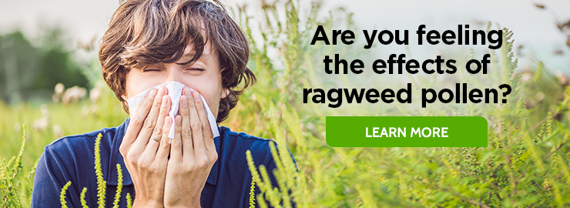
Allergies are an immune response triggered by allergens, which are very common, but harmful substance for some of us.

Causes
People with allergies have especially sensitive immune systems that react when they contact allergens.
Common allergens include:
foods (nuts, eggs, milk, soy, shellfish, wheat)
pollen
mold
latex
pet dander

Symptoms
Because there are so many possible causes, the symptoms of allergies vary widely.
Airborne allergens, like pollen and pet dander, are likely to cause:
Eye irritation
Runny nose
Stuffy nose
Puffy, watery eyes
Sneezing
Inflamed, itchy nose and throat
Allergens that are consumed, like foods or certain medications, can cause:
Hives or skin rashes
Gastrointestinal distress (diarrhea, nausea, vomiting, excessing gas, indigestion)
Tingling or swelling of the lips, face, or tongue
Itchiness
Difficulty breathing or wheezing
Fainting/ or lightheadedness
In cases of a more extreme response, called anaphylaxis, symptoms are severe and life-threatening.

Treatment
The easiest and most effective way to treat allergies is to get rid of or avoid the cause. Where unavoidable, some lifestyle changes can reduce your allergy symptoms. For example, if you are allergic to dust mites, make an effort to keep your room clean and free of dust by frequent vacuuming, dusting, and washing of bedding.
For pollen allergies, avoid being outside when pollen counts are high and keep the windows to your room shut.
Because it is very difficult to avoid certain allergens, medication may be necessary to lessen symptoms caused by allergens. Some allergies go away with age, but others are lifelong.

Prevention
•Avoid the outdoors between 5-10 a. m. and save outside activities for late afternoon or after a heavy rain, when pollen levels are lower.
•Keep windows in your living spaces closed to lower exposure to pollen.
•To keep cool, use air conditioners and avoid using window and attic fans.
•Discuss a prescription with your healthcare provider, if you have risk of serious allergic reaction.
•Know what you are eating or drinking.

Diarrhea

Causes
- Bacterial infection, caused by contaminated food or water
- Viral infection
- Parasites, which can enter the body through food or water
- Food intolerance, such as the inability to digest lactose, the sugar in milk
- Overuse of alcohol or laxatives
- Medication, such as some antibiotics or antacids containing magnesium
- Menstrual cramps
- Stress or a panic attack
Symptoms
- watery, loose stools
- frequent bowel movements
- cramping or pain in the abdomen, nausea, bloating
- possibly fever or bloody stools, depending on the cause

Treatment
- Usually diarrhea will clear up on its own in a day or two, but a prolonged case may cause complications. The most important concern is dehydration. If you have symptoms of dehydration, a fever above 102° F, bloody stools (black and tarry), severe abdomen or rectum pain, or diarrhea lasting more than 3 days you should consult a physician. Here’s some advice for taking care of diarrhea yourself:
- Avoid foods that are milk-based, greasy, high-fiber, or very sweet because these are likely to aggravate diarrhea.
- Avoid caffeine and alcohol.
- Do not eat solid food if you have signs of dehydration (thirst, light-headed, dark urine). Instead, drink about 2 cups of clear fluids per hour (if vomiting isn’t present), such as sports drinks and broth. Water alone is not enough because your body needs sodium and sugar to replace what it’s losing.
- Avoid high sugar drinks, like apple juice, grape juice, and soda, which can pull water into the intestine and make the diarrhea persist.
- Don’t drink clear liquids exclusively for more than 24 hours.
- Begin eating normal meals within 12 hours, but stick to food that is bland and won’t irritate your intestine. Some doctors suggest the “BRAT “diet which includes foods that are low in fiber, fat, and sugar. BRAT stands for Bananas, Rice, Applesauce, and Toast.
- Use over-the-counter lactobacillus acidophilus capsules or tablets. These bacteria help maintain a healthy intestine, and are found in yogurt with live active cultures.
- Decrease level of exercise until symptoms are gone.

Headaches


- Everyone suffers the occasional mild headache, but if you experience debilitating pain and/or abnormally frequent headaches, you probably want to find relief. There are countless causes of headaches, which differ for each person, so you’ll have to do some experimenting to figure out the cause of your pain. Fortunately, the vast majority of headaches are primary headaches, not the result of underlying medical conditions. The three most common types are cluster, tension-type, and migraine.
- A cluster headache affects a specific point of the head, often the eye, and is characterized by sharp, piercing pain. Migraine and tension-type headaches are far more common. “Tension “headaches are now called “tension-type “headaches because pain is not only caused by stress, but also poor posture, depression, and even sexual activity. In fact, recent studies have shown a connection between low serotonin levels and so-called “tension “headaches.

Causes
- The cause of a headache is often elusive. Although it may seem that your head is pounding for no reason, there is always an explanation for pain. To find out the cause of your headaches, keep a log. Write down the date and time each headache starts and stops, the location of the pain, the nature and severity of the pain, and any factors that seem to trigger the headaches (food, stress, menstrual cycle, medicine, etc.).
Some of the many causes of headaches:
- Emotional and physical stress
- Fatigue
- Irregular sleep habits (sleeping too much or too little)
- Skipping meals
- Caffeine use or withdrawal
- Hormonal factors, such as menstruation
- Alcohol
- Some medicines
- Certain foods, including red wine, chocolate, aged cheeses, pickled foods, nuts, and aspartame
- Changes in weather, altitude, or time zone

Symptoms
- Just as the causes vary for each headache sufferer, so do the symptoms and severity of pain. Health professionals can often diagnose the type of headache you suffer based on your symptoms.
Symptoms of a migraine:
- pulsing or throbbing quality
- begins with intense pain on one side of the head, which eventually spreads
- felt on one or both sides of the head
- lasts several hours
- severe enough to interfere with routine activities
- may be accompanied by nausea or vomiting
- sometimes preceded by visual changes, such as an aura of zigzag lines or flashes of light
- light and noise can make the headache worse, while sleep tends to relieve symptoms
Symptoms of a tension-type headache:
- constant, dull ache
- felt on both sides of the head
- a feeling of squeezing or pressure
- does not usually interfere with routine activities
- lasts from 30 minutes to a few days

Treatment
- Ice pack held over the eyes or forehead
- Heating pad set on low or hot shower to relax tense neck and shoulder muscles
- Sleep, or at least resting in a dark room
- Taking breaks from stressful situations
- Regular exercise to increase endorphin levels and relax muscles. Even if you already have a headache, exercising may relieve the pain. However, intense exercise may bring on a headache.
- Occasional use of over-the-counter medicines such as acetaminophen, ibuprofen, or aspirin can relieve both migraine and tension headaches. *
- Prescription drugs for severe headaches
- * Overuse of pain medicine can actually result in more frequent headaches. Most pain-relieving medicines used to treat headaches can cause “analgesic rebound headaches “if used too often.

Prevention
- Be aware of early symptoms so you can try to stop the headache as soon as it begins.
- Don’t smoke, and if you do, quit.
- Don’t skip meals.
- Cut down on caffeine and alcohol (reduce caffeine intake gradually because withdrawal may cause headaches).
- Stop all over-the-counter medicines and herbal remedies.
- Maintain a regular eating and sleeping schedule.
- Exercise regularly.
- Incorporate relaxation activities into your daily routine, such as meditation, yoga, stretching exercises, and massage
- Improve your posture, possibly by adjusting your workstation.

Nausea and Vomiting

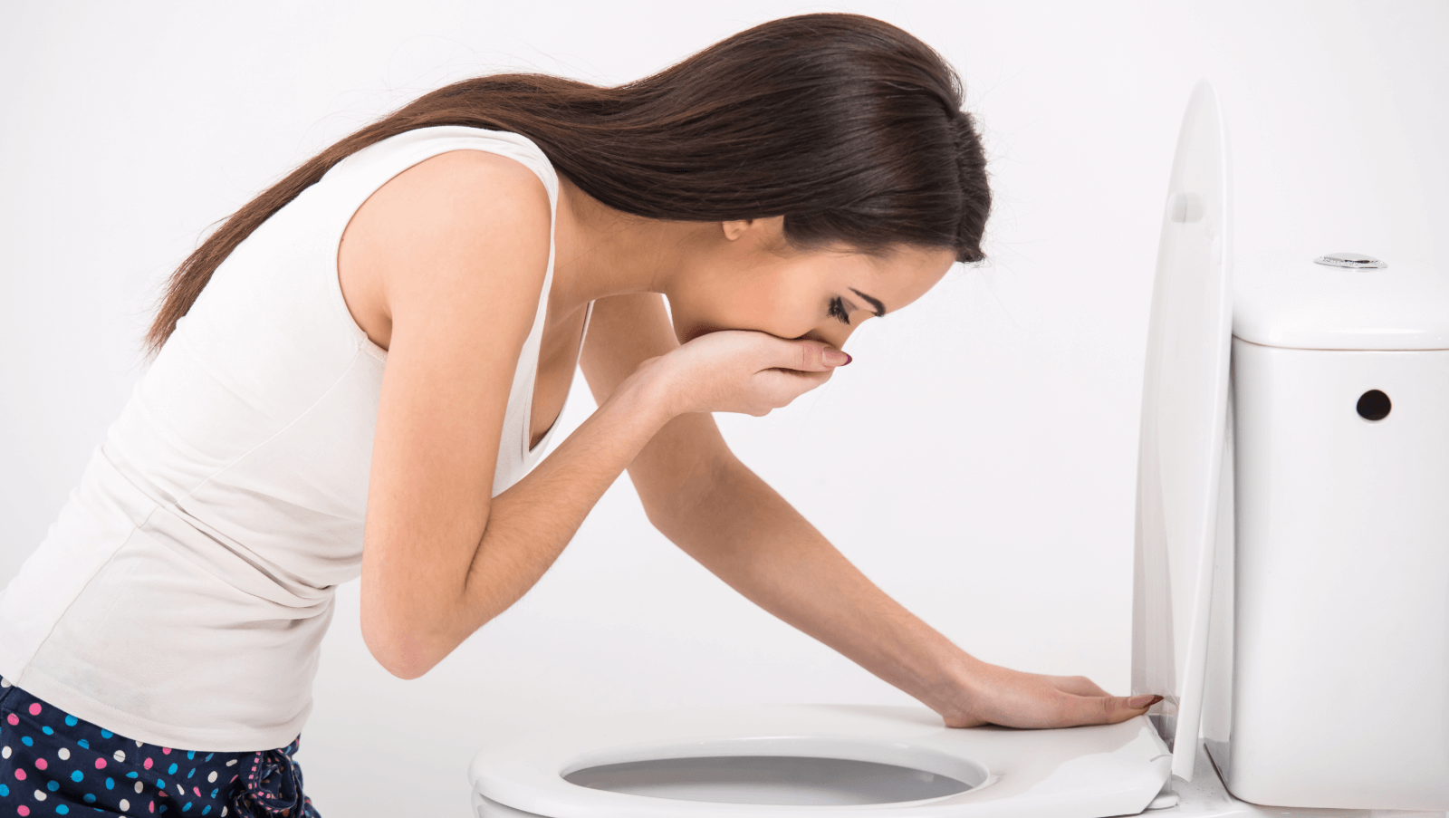
Possible causes for nausea and/or vomiting:
- Viruses in the intestines (viral gastroenteritis, see below)
- Some medications, such as certain antibiotics and birth control pills
- Eating too much or eating spoiled food
- Drinking too much (e.g. alcohol)
- Motion sickness
- Morning sickness in pregnant females
Medical conditions that cause vomiting:
- Concussion from a head injury
- Stomach ulcers
- Hepatitis (inflammation of the liver)
- Meningitis (inflammation of the membranes that cover the brain and spinal cord)
- Dehydration
Self-care tips for vomiting:
- Wait 30-60 minutes after vomiting before drinking anything to let your stomach settle.
- Don’t eat solid foods. Don’t drink milk.
- Drink clear liquids, taking small sips. Stir any carbonated beverages to get all the bubbles out before sipping them. Suck on ice chips if nothing else will stay down.
- Gradually return to regular diet, but wait about 8 hours from the last time you vomited. Start with foods like dry toast, crackers, rice, and other foods that are easy to digest.
- Avoid foods and medications that irritate the stomach, like alcohol, aspirin, and fried foods.
- Avoid caffeine and alcohol, that contribute to fluid loss.

When should I see a health care provider?
- If you can’t keep liquids down for more than 24 hours
- If you have blood in vomit or stools
- If you’re vomiting for more than 1 day

